Background

Prostate cancer (PC) is the second most common cancer in the US with an estimated 268,490 new cases in 2022 (14% of all new cancer cases) and an estimated 34,500 deaths in 2022. Most cases are localized, but 7% have distant metastasis and a poor 5-year survival (1).
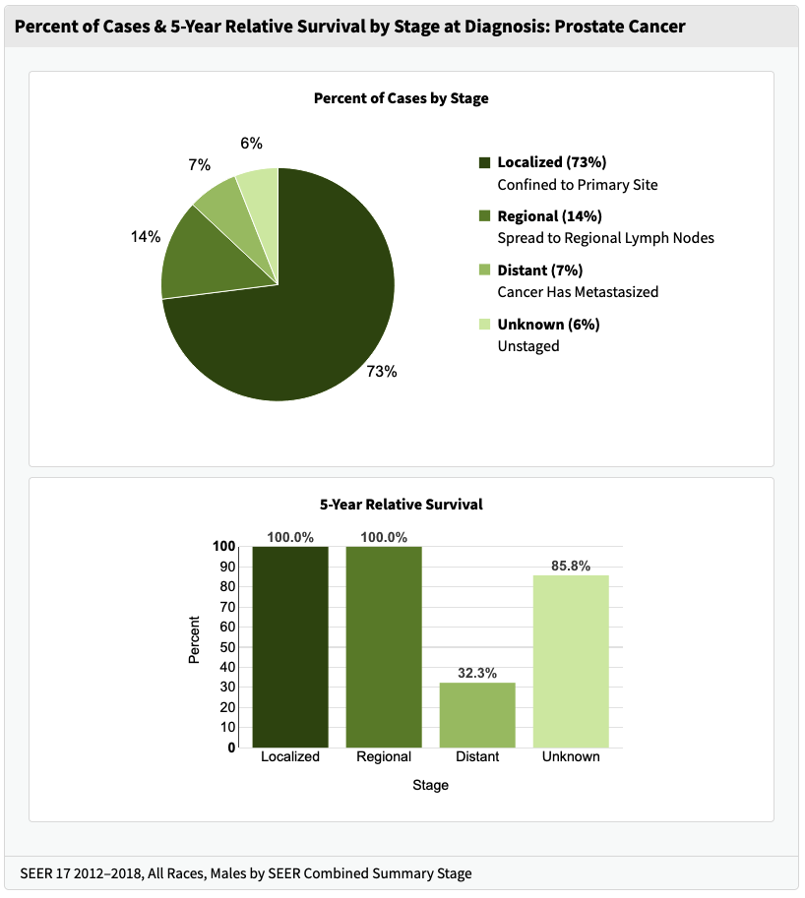

Figure 1. Percent of cases by stage and 5-year survival by stage. (https://seer.cancer.gov/statfacts/html/prost.html)

Patients at highest risk for death are those over 75 years of age (66% of PC deaths), with the highest proportion in Non-Hispanic Black individuals (37.9 deaths/100,000 persons for NHB compared to 18.9 deaths/100,000 persons for all races combined). However, many patients diagnosed with PC may not die from their cancer but will die from other illnesses even without curative cancer directed therapy. This is important since both local control measures (surgery, radiation) or hormonal therapy have the risk of significant side effects. Clinical markers such as prostate specific antigen (PSA) levels and Gleason score have been used to risk stratify patients, but biomarkers are needed to further identify who may benefit from treatment in the highest risk groups (2).

The development of malignancy is a complex process which involves inherited gene risk factors, changes to the cellular genome by DNA damage and epigenetic changes, and resulting changes in the metabolome and transcriptome. Additionally, the ability of transformed cells to avoid immunosurveillance can be influenced by the metabolome of the cancer cells and the body’s microbiome (3,4). The ability to measure the genome, epigenome, transcriptome, and metabolome (omics data) of tumors samples or even at the single cell level has provided a large amount of data in cancers. The Cancer Genome Atlas (TCGA) is one available repository of this data available to researchers to help understand the molecular basis of cancer (5). Omics data has been analyzed individually in many studies to look for biomarkers of disease outcomes. Integration of omics data prior to analysis may help give a bigger picture of the relationship between data sets, but is difficult due to the high dimensionality of the data. Machine learning methods can help with the feature extraction and integration of complex data sets (6). They can also help find biomarkers in the data sets that can provide clinically useful insights which can help with cancer diagnosis, risk stratification, and biologically relevant treatments.

In this study we will use transcriptome and methylation data from TCGA and integrate it with genomic and phenotypic data using a machine learning model. We will then use this integrated data to look for biomarkers which correlate with outcome measures such as disease recurrence, metastasis, and rise in PSA level. A web facing app to visualize the data will be developed to allow exploration of the data by clinicians and researchers without extensive data science training.
References

1. Seer data, prostate cancer. https://seer.cancer.gov/statfacts/html/prost.html

2. Terada et al. Prognostic and predictive biomarkers in prostate cancer: latest evidence and clinical implications. Ther Adv Med Oncol. 2017 Aug; 9(8): 565–573.
https://doi.org/10.1177/1758834017719215

3. Joseph et al. Metabolic features of cancer cells impact immunosurveillance. J Immunother Cancer. 2021 Jun;9(6):e002362
https://dx.doi.org/10.1136/jitc-2021-002362

4. Zitvogel et al. Microbiome and Anticancer Immunosurveillance. 2016. April; 165(2): 276-287.
https://doi.org/10.1016/j.cell.2016.03.001

5. The Cancer Genome Atlas (TGCA). https://www.ncbi.nlm.nih.gov/projects/gap/cgi-bin/study.cgi?study_id=phs000178.v11.p8

6. Uyar et al. Multi-omics and deep learning provide a multifaceted view of cancer. 2021. (preprint- bioRxiv) https://doi.org/10.1101/2021.09.29.462364

